BC2402: Designing and Developing Databases

Week 6 Class Exercises – Advanced SQL

Case: Socialgram

Socialgram is a new social media platform in which users can interact with others using text, voice, and video content. Each user has a personal profile that contains his/her name, gender, and age. A personal profile contains at least one photo and one video clip. Photos can be organized into albums. An album contains at least one photo, but oftentimes contains multiple photos. A photo may appear in zero or multiple albums. Since a photo or video clip may be relevant to multiple users, the photo or video clip may be kept in at least one profile (or multiple profiles).

A user can follow other users. Other users may follow him/her. At times, users can be mutually following each other. Socialgram helps users visualize their immediate networks (i.e., those following Ben and those being followed by Ben) and extended networks. Users must specify at least one interest from a list of predefined interests to help Socialgram determine relevant social content (e.g., photos posted by followees) for users.

A user may create groups to facilitate focused discussions or interactions. Groups are typically created around certain topics, such as sports, hobbies, movies, etc. The creator of a group is the administrator of the group. A group can have a maximum of 200 members (i.e., other users). The creator may authorize members to become administrators. Some users can be banned from the group.

Entities and Attributes
Entity | Attributes
User | UserID, Name, Gender, Age
Photo | PhotoID, FileSize, Resolution, FileLocation, DateCreated
Video | VideoID, FileSize, Format, Compression, FileLocation, DateCreated
User-Photo | (UserID), (PhotoID)
User-Video | (UserID), (VideoID)
Album | AlbumID, (UserID), (PhotoID), AlbumName, DateCreated
User-Following | (UserID), (FollowingUserID)
Interest | InterestID, InterestName
User-Interest | (InterestID), (UserID)
Group | GroupID, GroupName
User-Group | (GroupID), (UserID), isCreator, isModerator, isBanned

Required:
Using the information provided above, specify the SQL syntax for the following queries:

1. List the names of users who are group moderators.

Sample output:
name
Ben Choi
Jayden Johnson
Cammy Soh

2. List the names of users who are banned in more than 1 group.

Sample output:
name
Jackie Tan

3. List the names of users and total filesize of each user’s photos when the total filesize of his/her photos is larger than 1000.

Sample output:
name | Total_Photo_Filesize
Ben Choi | 52343
Jayden Johnson | 1870918
Cammy Soh | 1251143

4. List the names of albums (and the number of users owning the album) in which at least one photo belongs to more than 1 users.

Sample output:
Albumname | total_users
Nice Album | 2
The Picnic Days | 2

5. List the userid and user names of those who are following each other. For example, Ben Choi is following Jackie Tan and Jackie Tan is following Ben Choi.

Sample output:
userid | userName | following_userid | following_userName
881 | Ben Choi | 884 | Jackie Tan
881 | Ben Choi | 882 | Jayden Johnson
881 | Ben Choi | 883 | Cammy Soh
882 | Jayden Johnson | 881 | Ben Choi
883 | Cammy Soh | 881 | Ben Choi
884 | Jackie Tan | 881 | Ben Choi

6. List the users who are involved in relational triads. For example, Ben Choi is following Jayden Johnson, Jayden Johnson is following Cammy Soh, Cammy Soh is following Ben Choi.

Sample output:
User1 | User2 | User3
Ben Choi | Jayden Johnson | Cammy Soh
Ben Choi | Jayden Johnson | Jackie Tan
Jayden Johnson | Cammy Soh | Ben Choi
Jayden Johnson | Jackie Tan | Ben Choi
Cammy Soh | Ben Choi | Jayden Johnson
Jackie Tan | Ben Choi | Jayden Johnson

Case: The Steps Challenge
To motivate sustainable active lifestyle, Nanyang Wellness organises a Steps Challenge (SC), in which participants are rewarded for completing steps goals. For every 100 steps, participants earn one basic SC point, which can be accumulated to redeem gifts and cash vouchers. Additionally, participants take part in weekly steps goal challenges (e.g., to complete 50,000 steps in one week). By completing the weekly steps goals, they receive bonus SC points (e.g., 10,000 points), which are awarded in addition to basic SC points (100 steps = 1 basic SC point).

The ER diagram below models the database of the Steps Challenge Information System. The notations and the symbols in the ER diagram carry the usual meaning.

ER Diagram
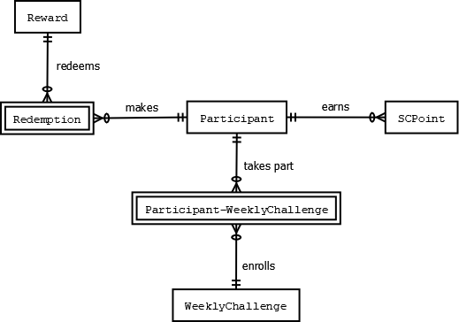

Entities and Attributes
Entity | Attributes
Participant | ParticipantID, Name, Age, Gender, Address
SCPoint | DateEarned, TimeEarned, BasicPointsEarned, ParticipantID
Reward | RewardID, RewardName, RequiredSCPoints
Redemption | RedemptionID, RedemptionDate, RewardID, ParticipantID
WeeklyChallenge | WeeklyChallengeID, WeeklyChallengeName, BonusAmt
Participant-WeeklyChallenge | ParticipantID, WeeklyChallengeID, EnrollmentDate, Status

Required:
Using the information provided above, specify the SQL syntax for the following queries:

- Retrieve a list of the names of participants.
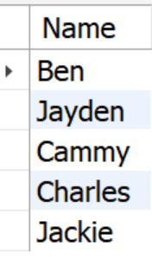
- List the names of all participants who have enrolled in more than 2 weekly challenges.
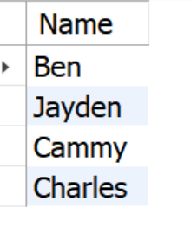
- What is the number of participants who have redeemed at least one “Car Wash at Caltex”?
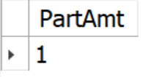

- List the names of participants who have accumulated more than 10,000 SC points and have redeemed at least one “Car Wash at Caltex”?
